PS – LAB 5

IT24101774

Nasrulla M U

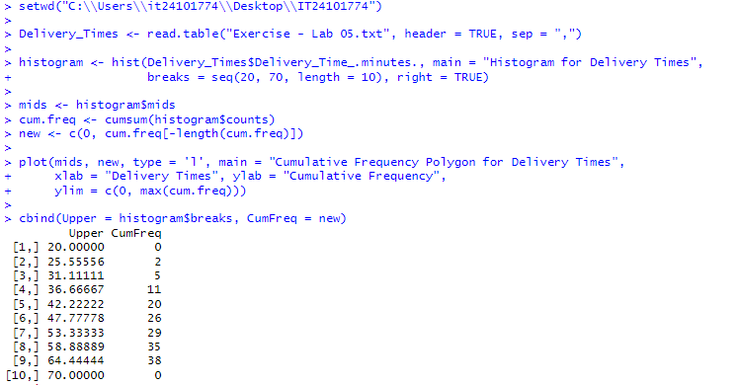

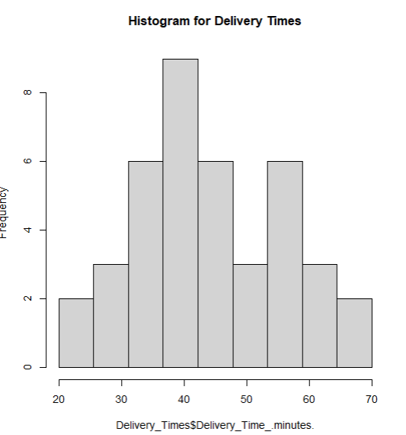

Explanation of the shape of the plot:

The two halves of the histogram, on either side of the peak, are almost symmetrical. It also resembles a bell shape as well.

The data is dense in the middle indicating very short and very long delivery times are less common

